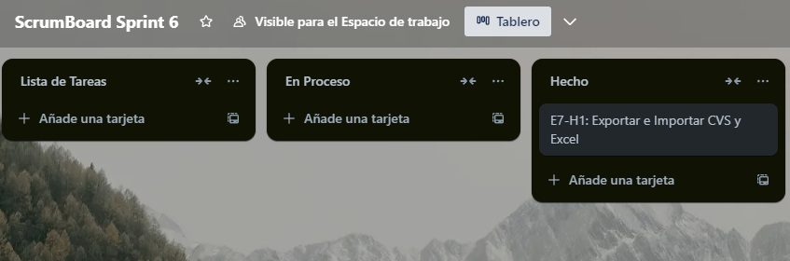

<https://trello.com/b/Y3bDkfMf/scrumboard-sprint-6>